Deliverable 3

|  |  |
| --- | --- |
| Course: | SEG2105 |
| Professor: | Miguel Garzon |
| Group: | sudo rm –rf / |

November 24, 2017

|  |  |
| --- | --- |
| Jonathan Popowick-Bastien: | 8432984 |
| Ryan Ethier: | 8606056 |
| Joshua Vinge: | 8655939 |
| Walter Wong: | 8752209 |

**3 Screenshots of UI**

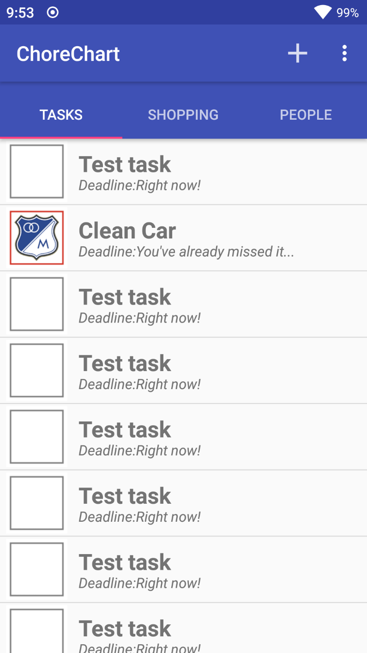Pictured to the left is a screenshot of the tasks tab. This tab is where the user can view pending tasks and view when they are due.

In addition, the title bar allows you to add a task to the list.

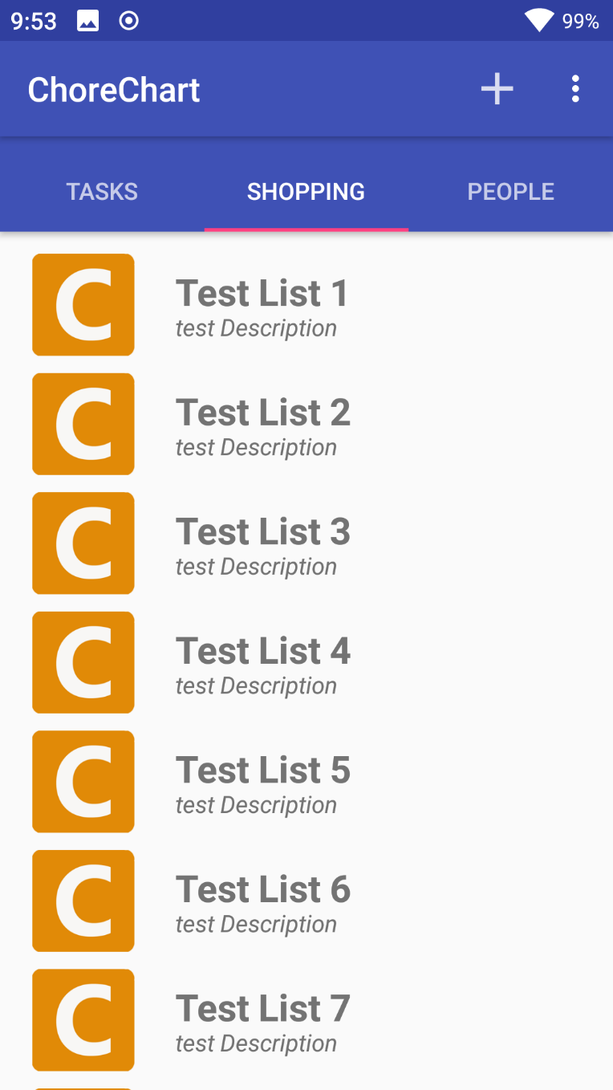Pictured to the left is the shopping tab. This tab allows users to browse lists containing various sub lists of shopping items. Tapping a list will expand the list to display the sub items (not functionally implemented yet).

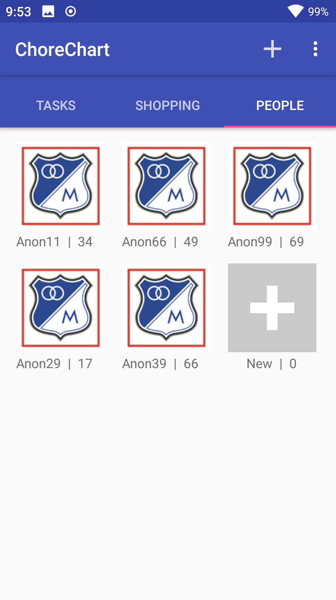Pictured to the left is the people tab. From this screen, you can view all the users currently stored in the app, and can tap on them to edit/view their details (not functionally implemented yet). The preview cards show the user’s name as well as their points score for how many points they’ve achieved by completing tasks. New users can easily be added by tapping the new user button at the end of the list.